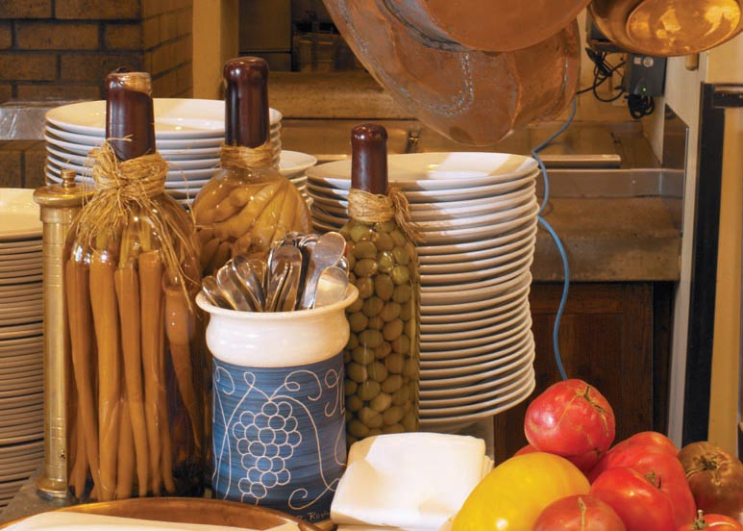

A Touch of European Café

 

www.atouchofeuropeancafe.com

**7146 North 57th DR., Glendale, AZ 85301**

**Phone: 623.847.7119**

## -B.Y.O.B. - beer or wine only

Established 2003

**Dine-in or Take-out, catering available**

Mozzarella Sandwich – *sliced fresh mozzarella, tomato &basil on ciabatta bread w/house*

*balsamic dressing (add turkey breast or prosciutto ham or salami - $3.00) ….......*$12

Kielbasa Sandwich – *(smoked polish sausage) on sub roll or ciabatta bread with cold*

*sauerkraut-slaw...………………………...………………………….………….…….….* $13

Chicken Sandwich *– breaded chicken cutlet&cheese on ciabatta bread…………....…….... …….. .* $15

House Sandwich – *turkey, ham, bacon, and provolone cheese on ciabatta bread …….……..….… .*$13Italian Sub – *ham, salami, provolone cheese on ciabatta or sub roll ………....……………….….. ...* $13

Ham Sandwich – *black forest ham and provolone or swiss cheese (your choice of bread) ….…....*$12

Grilled Prosciutto Sandwich - *Prosciutto ham and provolone cheese with olive oil and fresh basil on ciabatta bread……………………….………………………………………………………….….……….......*$13

Turkey &Cranberry Sandwich - *turkey breast & cranberry* *sauce (your choice of bread) ...........*$12

Reuben-*Turkey pastrami, swiss cheese, sauerkraut,1000’s Island dressing on ciabatta bread …....*$12

Liverwurst Sandwich – *(Braunshweiger) liverwurst (your choice of bread) …….………………….* $11

Panini Croissant Sandwich - *grilled croissant with cheese, ham or turkey and mushrooms ..........*$12

Melty Cheese & Bacon Sandwich – *swiss and provolone (your choice of bread) ……………...…..*$11

Chicken Salad Sandwich – *chicken breast w/shredded carrots, dry cranberries and sliced*

*almonds on apricot – walnut bread ……………….……………………..........*$12

BLT Sandwich – *bacon, lettuce & tomato (your choice of bread) …. ……………..………………...* $11

Egg Salad Sandwich – *diced hard boiled eggs with green onions, mayo, mustard and pepper*

*(your choice of bread) ………………………….………………..…..……….…...*$10

Solid White Albacore Tuna Salad Sandwich – *tuna with celery seeds, mayo, mustard and pepper (your choice of bread) …………………………………………………………………………………….…..*$11

* *All sandwiches served with potato chips or fruit. If you would like a dill pickle please ask for one!*
* *Choice of bread: white, wheat, multigrain, dark country, rye, apricot-walnut, sub roll, croissant and ciabatta*
* *Choice of cheeses: provolone or swiss cheese*
* *Optional items: tomato, red onion, mayo, mustard, graded horseradish, cranberry sauce or dressing*

Over 50 kinds of homemade rotating variety of soups served daily. Ask for today’s special.

Bowl of Soup - $9

Cup of Soup - $6

www.atouchofeuropeancafe.com

Gourmet Sandwiches

Appetizers

6 Pierogi (Polish Dumplings) – *your choice of potato-cheese or sauerkraut-mushrooms ….……...*$12

BYOB Platter – *variety of cold cuts and cheeses with pickles, mustard and toasted ciabatta bread served on a wooden board …………………….………….………………………………………………..…*$15

Capri Salad – *sliced fresh mozzarella cheese, sliced tomato, basil with house balsamic*

*dressing and toasted ciabatta bread …….……………………………….…...…………..*$13

Kielbasa Appetizer – *simmered sliced Polish sausage with bacon & onions served with toasted ciabatta bread and dill pickles….…………………………………………………………………........……*$14

Marinated Pickled Herring – *served with onions and rye bread……………………….……….…....* $11

Main Dishes

Polish Sample Platter – *3 pierogi, a cabbage roll, scoop of hunter’s stew and a piece of polish*

*sausage (smoked or fresh kielbasa) served w/ bread basket……….….……*$25

Pierogi Platter (Polish Dumplings) – *sautéed with onion and butter 1doz -....*$22 ….. *.1/2doz -…* $12

Combo – *6 potato-cheese pierogi and smoked kielbasa sautéed with onions and butter...……..…...*$20

Kielbasa Platter – *fresh and smoked kielbasa with mashed potatoes and a side order ……............*$19

3 Cabbage Rolls – *stuffed with ground pork meat and rice served w/ bread basket ……...………...*$18

Hunter’s Stew – *cabbage &sauerkraut dish with mushrooms, dry plums, sautéed onions and*

*cooked with red wine, served over noodles with smoked kielbasa ………..............*$19

Hungarian Pork Goulash – *cooked with celery, carrots, garlic and paprika served over noodles*

*with a side order ………..……………………………………………….…..*$19

Breaded Chicken or Pork Cutlet – *(schnitzel) with mashed potatoes and a side order ….............* $20

* *Your choice of side orders includes shredded pickled beets with onions, green beans,*

*cold sauerkraut-slaw, or dill pickles…………………...……………………………….……..…*$5

Salads

Caesar Salad - *romaine lettuce, tomatoes, croutons, caesar dressing & dressed with*

*parmesan cheese……………………………….………..…*Large - $10………Small – $7

Greek Salad - *romaine lettuce, tomatoes, fresh cucumbers, sliced black olives, red onions,*

*crumbled feta cheese, dry oregano & house dressing......*Large - $13...........Small – $10

House Salad - *romaine lettuce, tomatoes, fresh cucumbers, red onions, and dried cranberries with your choice of dressing …………………………………………….……...…*Large - $11...........Small – $8

Capri Salad - *fresh mozzarella, sliced tomato and fresh basil w/ balsamic dressing …………..…..* $13

* *Scoop of chicken, tuna, or egg salad on top of the salads ………………..……....……..…….*$5
* *Add grilled chicken breast strips on top of the salad ………....*Large *-* $5………..Small – $4
* *Your choice of dressing includes Italian, Ranch, House Balsamic Vinegar, 1000’s Islands, Creamy Caesar, Raspberry Balsamic, Greek Dressing*

## Entrees

www.atouchofeuropeancafe.com

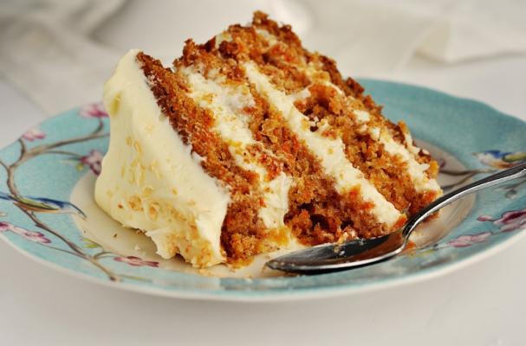

## Desserts & Beverages

Desserts

Cheese Blintzes (Nalesniki) - .*…….…...…*$10

Chocolate Cake - *……….……..….……..…..*$6

Poppy Seed Cake - …….…..….….…..…..$6

Homemade cake - …….……..……..…….$6

Carrot Cake - …….………..………..……$6

Chrusciki (Angel Wings)….………..……$9

Coconut Macaroon Cookie .………..…$3.50

Baklava …………………….…………. $2.50

Brownie…………………………………$3.50

Kolaczki……………………….…(1Doz.)...$9

Beverages

Iced Tea or Coffee *…….…….….…..…….…*$3

Mango Passionfruit caffeine free herbal

Iced Tea ….............................................$3.50

Ice Carmel or Mocha Coffee ...…….….…$4

Canned Soda ……………..…...……...…....$2

Bottled Water ……………….………..……$2

Milk ……………….…………….….... ...$2.50

Espresso………..……….………….………$3

Hot Coffee or Tea ……………….………..$3

Cappuccino …………………………....$4.50

Café Mocha or Café Latte …………….$4.50

Variety of herbal or fruit teas ...…...….$3.50

Hot Chocolate ……………….……...….$4.50

Carmel Apple Cider ………….…......…$4.50