CULINARY TOUR IN POLAND AND CZECH REPUBLIC 2026
15 days/14nights of feasting and fun!
Dates: June 6th –June 21st. 2026, OR Aug. 8th – Aug. 23rd. 2026
Warsaw, Olsztyn, Poznan, Prague, Krakow, Warsaw
June 6-9 OR AUG. 8-11 Warsaw - The Polish capital, largest city, and the best place to meet to see what Poland has to offer. We will visit the Royal Castle, a beautiful old town, and experience the rich history, museum, culture, and food.
June 9-12 OR AUG. 11-14 Olsztyn - is the largest city in Warmia, which is part of a larger historical region called Prussia. Olsztyn is in the north-east part of Poland in the region known as the "Thousand Lakes”. Olsztyn is a place where the culinary traditions of Warmia and Masuria meet modern trends, regional specialties such as "dzyndzałki" (meat-filled dumplings) or "farszynki warmińskie" (potato patties) and often featuring fresh fish from Masurian lakes.
June 12-14 OR AUG. 14-16 Poznań - City on the Warta River in west-central Poland, in the Greater Poland region. It is best known for its renaissance Old Town and Ostrów Tumski Cathedral. Poznań is the fifth largest and one of the oldest cities in Poland. Poznan cuisine features dishes like St. Martin’s croissants and gołąbki are essential to the local food culture.
June 14-17 OR AUG. 16-19 Prague- This capital city is known for its Old Town Square, with colorful baroque buildings, Gothic churches, and the medieval Astronomical Clock. We will also walk on Charles Bridge, lined with statues of Catholic saints, and experience the oldest largest castle in Europe.
June 17-20 OR AUG. 19-22 Krakow – This city was previously the royal capital of Poland for centuries and is one of Poland’s most important economic hubs. We will visit Wieliczka Salt mine, Cathedral-Wavel Castle and later we will be sightseeing in Krakow by cruising along the river. We will experience “Farmers Market” and more.
June 20-21 OR AUG. 22-23 Warsaw - Arrive at Warsaw hotel located near the airport. We will have a farewell dinner. Next morning you’ll have your final breakfast and take a quick walk to Okecie Airport to catch your plane home.
$7.000 Per Person (Based on two guests per room) Land only.
$750 p.p. (non-ref) deposit to hold the space. Credit card payments 3.99% processing fee. SPACE IS LIMITED TO 15 PEOPLE MAXIMUM.
Handpicked restaurants with the ability to sample cuisine from around the country, visits to popular destinations such as Wieliczka salt mine, Cathedral-Wavel Castle, Boleslawiec the famous Polish pottery, Astronomical Clock, Charles Bridge, and much, much more!
The tour includes: 5-star hotels, daily breakfast and dinner, site trips, all ground transportation in a luxury, air-conditioned coach, local tour guides, entry to museums.
* Gratuities not included.
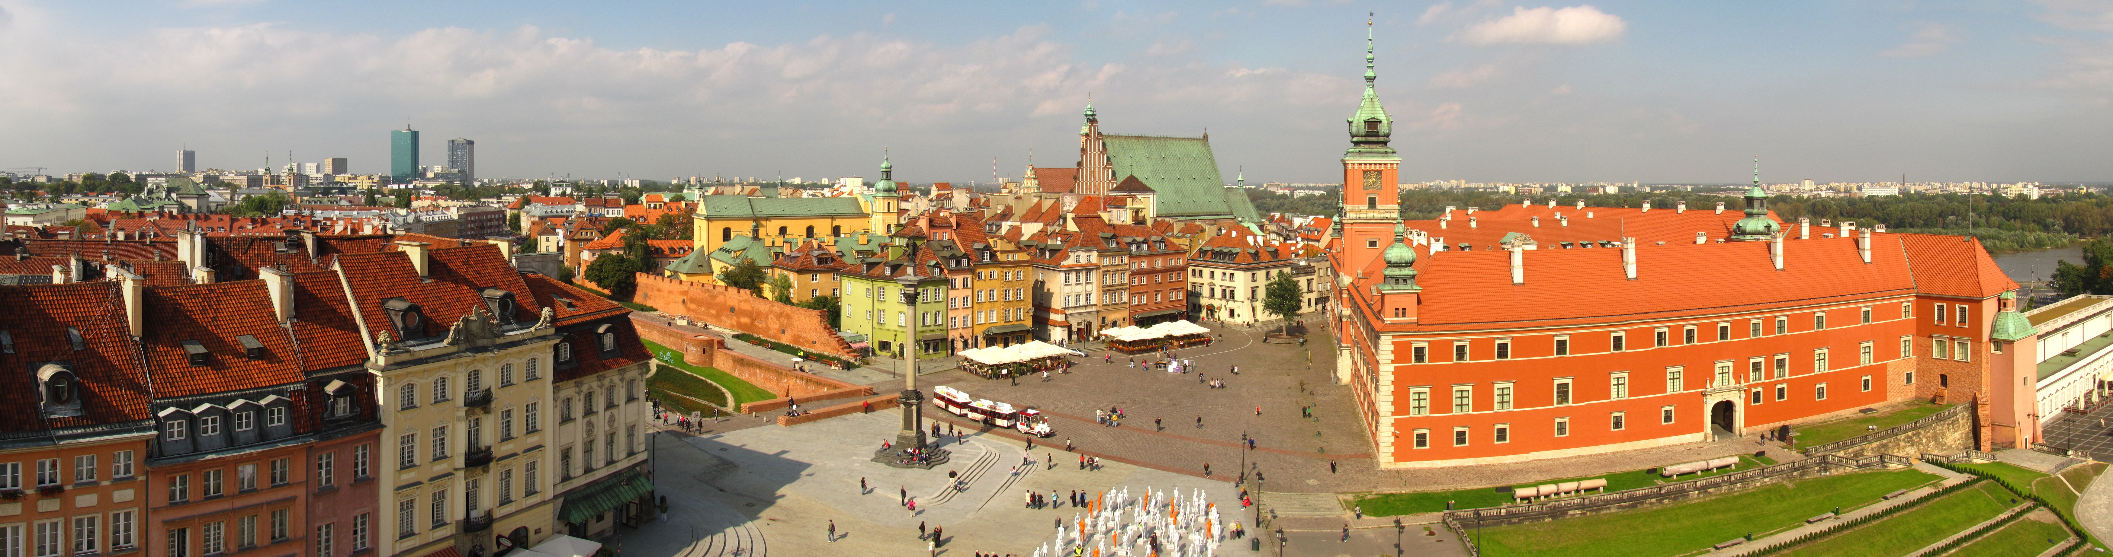

“Polish history and heritage meet culinary experience.”
Reservation and inquiries: A Touch of European Café 623.847.7119

